How to Use Beagle Bone Drone

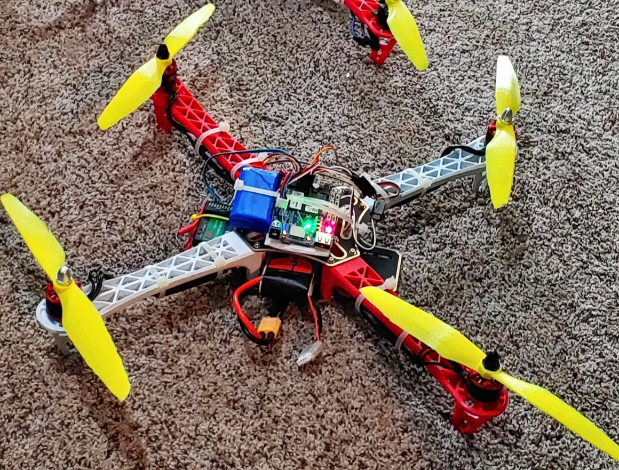

Table of content

1. How to startup Beagle bone Drone
2. Drone Check List
3. How to use mission planner
4. Raspberry Pi Interfacing
5. Controller Setup

Setting up the Beagle bone drone

To setup the Beagle bone drone you will need-

* Beagle bone Drone
* LIPO Battery (3S)
* Remote Control
* Laptop Computer
  + Charged
  + Wifi Connection

Drone Check list

|  |  |  |
| --- | --- | --- |
| Date: Location: | Check | Comments |
| Charged Battery |  | Volts: MAH: |
| Check props tight on motor |  |  |
| Secure battery and cargo |  |  |
| Plug in battery |  |  |
| Check Radio Connection on mission planner |  |  |
| Check surroundings of drone operation area |  |  |
| Arm Drone |  |  |
| Landed |  |  |

Comments on flight:

Crashed drone : Yes or No and # ___ and comment:

Using putty

Putty is a ssh’ing program that will allow you to remotely connect to the Beagle Bone board. This program is available at <https://www.chiark.greenend.org.uk/~sgtatham/putty/latest.html>

To connect via putty you will 1) open up the putty application 2) Type the ip address of beagle bone in host name text box (if plugged in via usb the ip is 192.168.7.2). 3) Hit the open button and you should be greeted by a login screen if not the Beagle Bone is still booting up. The login info by default is (username: debian),(password : temppwd). 4) To manually start the Beagle Bone program you will want to enter the following commands.

* /bin/echo 80 >/sys/class/gpio
* /bin/echo out >/sys/class/gpio/gpio80/direction
* /bin/echo 1 >/sys/class/gpio/gpio80/value
* /bin/echo pruecapin_pu >/sys/devices/platform/ocp/ocp:P8_15
* sudo /home/debian/arducopter -C udp:192.168.1.16:14550
  + replace 192.168.1.16 with your laptops ip address

How to use Mission Planner

Screenshot of Mission planner (1.3.68)

Mission planner is the software that is used to control the drone. It has a lot of different options that can be used to tune the drone flight model. This can highly change how the drone flies but if the drone is already setup mission planer is easy to use.

The first thing you’ll want to do is go thru the checklist provided and make sure drone flight is ready. When you are ready to connect to drone, you’ll chose the correct connection info for this it will be udp then hit the connect button. The drone’s information will load onto the laptop thru the WIFI. This will allow us to arm the drone and the drone’s motors will start to spin up and it will be ready to fly. Be careful to keep the drone within the WIFI signal zone to enable good connection.

Controller setup

Binding controller to receiver: <https://youtu.be/9-Z0rTVEkHI?t=80>